Supplemental Primary Source Documents

Document C

To Inform All Masters of Vessels
(Transcription modified for length and clarity.)
This notice was placed in The Boston Evening Post newspaper, January 2, 1764. It is “signed” by two officers of the British Customs Service in Salem. The notice directs captains who trade at non-British colonies in the West Indies to pay the required duties on rum, sugar, and molasses. It references the 1733 Molasses Act (“Act of the Sixth of his late Majesty King George the Second”), which merchants largely ignored. The Sugar Act was passed three months after this notice was published, on April 5, 1764.

Custom-House December 26, 1763.
Port of Salem,
It has been reported to the honorable Lord Commissioners of his Majesty’s treasury, that many vessels trading at the plantations not belonging to the King of Great-Britain, and returning with cargoes of rum, sugar, and molasses, have found means to smuggle the same into his Majesty’s colonies, without paying the King’s duty. This is to inform all masters of vessels using the said trade, that they are hereby strictly required on their arrival here, to enter or report their ships and cargoes at the Custom House. Then proper Customs Officers will be put on board such vessels to see that the Act of the Sixth of his late Majesty King George II (imposing
a duty on all foreign rum, sugar, and molasses) be in all parts fully followed.
By Order of the Surveyor-General,
J. Cockle, Collector.
J. Dowse, Surveyor & Searcher

Vocabulary
- Vessel: a ship or boat
- Duty: a tax collected by the government
- Masters: ship captains
- Custom House: the government office where British Customs Officials collected taxes on imported cargo.
- Act of the Sixth: the 1733 Molasses Act, predating the 1764 Sugar Act.

Document C

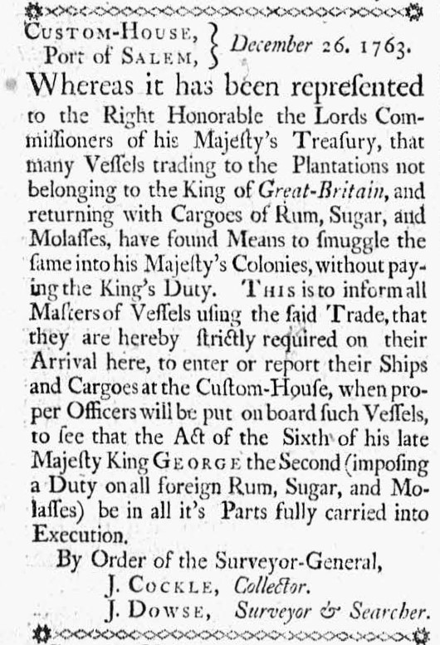

Image Source
“The Boston Evening Post.” January 2, 1774. Courtesy of Readex: America’s Historical Newspapers. Early American Newspapers, Series 1: From Colonies to Nation.

Document C
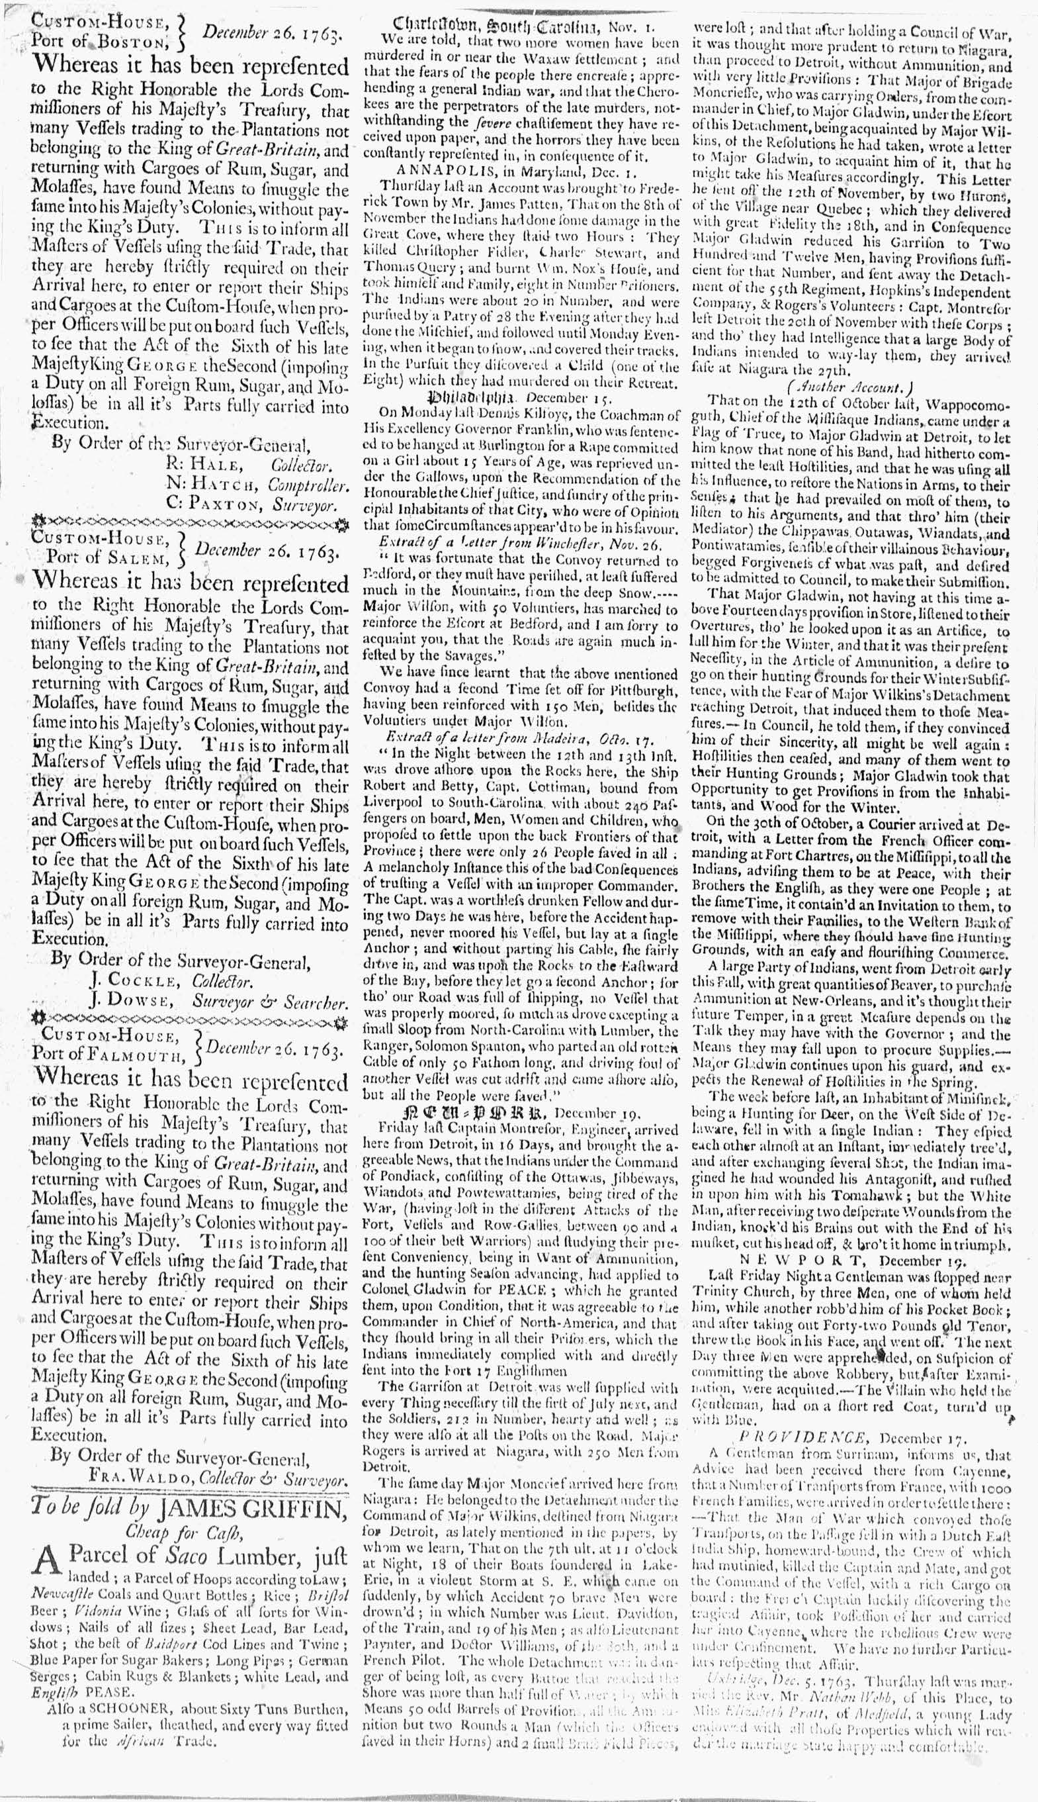

Image Source
“The Boston Evening Post.” January 2, 1774. Courtesy of Readex: America’s Historical Newspapers. Early American Newspapers, Series 1: From Colonies to Nation.

Document C

112 Gallons of Rum to Hannah Pratt
(Transcription modified for length and clarity.)
Richard Derby was a Salem merchant, ship owner, and owner of a rum distillery in Salem. This is a record of rum purchased and received by Hannah Pratt. Pratt states she will pay required taxes and is licensed to sell rum in Salem. Pratt owned and operated a well-known tavern in Salem, the Blue Anchor in Town House Square. Pratt inherited the tavern from her mother, widow Margaret Pratt.
Following the death of a husband, 18th century women gained a new level of economic freedom and responsibility. They had the power to hold and manage their own property and earnings. But some widows became working women out of necessity to support themselves and their families. Many were licensed to sell alcohol and did so from their homes, shops, or even outside as a form of “poor relief.” Some gained significant success, owning and operating popular public taverns.

Salem November 27th 1762
Hannah Received from Richard Derby 112 gallons rum, the excise of
Pratt which I am to be accountable for being a licensed
person in Salem in the County of Essex. Hannah Pratt.

Vocabulary
- Excise: tax

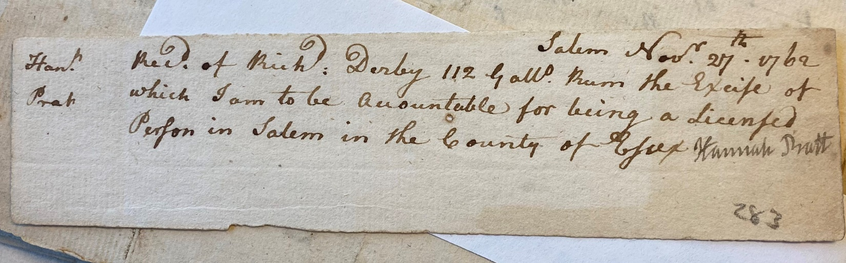

Image Source
MSS 37 Derby Family Papers, Box 14, Folder 9. Philips Library, Peabody Essex Museum, Salem, Mass. NPS Photo.

